**Microprocessors and Microcontrollers**

**Arduino Project**

Ashish Kumar (2019UCO1518)

Sandeep Jain (2019UCO1522)

Mayank Goel (2019UCO1558)

Gaurav Singhal (2019UCO1571)

Suraj Kumar (2019UCO1559)

Please check out YOUTUBE (link) for live demo.

**PROBLEM STATEMENT:**

Measuring CO2 Concentration in Air using Arduino and MQ-135 Sensor

**WHY WE CHOOSE THIS?**

* + The earth’s Atmospheric CO2 level is increasing day by day.
  + The global average atmospheric carbon dioxide in 2019 was 409.8 parts per million and in October-2020 it is 411.29.
  + Carbon dioxide is a key greenhouse gas and responsible for about three-quarters of emissions.
  + So CO2 level monitoring has also started to gain importance.
  + So,we felt a concern about insufficient ventilation in my room, and are curious about environment we live in!

**ABOUT PROJECT:**

* + Our proposal is a CO2 device that logs the data from the CO2 sensor onto an OLED Display Module for further analysis.
  + We are going to use an MQ-135 sensor with Arduino to measure the CO2 concentration.
  + The measured CO2 concentration values will be displayed on the OLED module
  + We will also compare the Arduino MQ-135 sensor readings with Infrared CO2 sensor readings.

**COMPONENTS REQUIRED:**

* + Arduino Nano
  + MQ-135 Sensor
  + Jumper Wires
  + 0.96 inch I2C/IIC 128x64 OLED Display Module 4 Pin
  + Breadboard
  + 22KΩ Resistor

**Arduino Nano:**

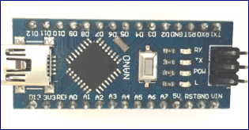

**Arduino Nano Pin Configuration:**

|  |  |  |
| --- | --- | --- |
| Pin Category | Pin Name | Details |
| Power | Vin , 3.3V,5V,GND | **Vin:** Input voltage to Arduino when using an external power source (6-12V).  **5V:** Regulated power supply used to power microcontroller and other components on the board.  **3.3V:** 3.3V supply generated by on-board voltage regulator. Maximum current draw is 50mA.  **GND:** Ground pins. |
| Reset | Reset | Resets the microcontroller |
| Analog Pins | A0 - A7 | Used to meansure analog voltage iin the range of 0-5V |
| Input / output pins | Digital pins D0 – D13 | Can be used as input or output pins . 0V (low) and 5V (high) |
| Serial | Rx,Tx | Used to receive and transmit TTL serial data |
| External interrupt | 2,3 | To trigger an inteerupt |
| PWM (pulse width modulation) | 3,5,6,9,11 | Provide 8 bit PWM output |
| Inbuild LED | 13 | To turn on the inbuild LED |

### ****Arduino Nano Technical Specifications:****

|  |  |
| --- | --- |
| Operating voltage | 5V |
| Input voltage for Vin pin | 7 – 12 V |
| Analog input pins | 6 (A0 – A5) |
| Digital i/o pins | 14 |
| Frequency (clock speed) | 16MHz |
| SRAM | 2Kb |

**MQ-135 Sensor:**

There are various gas sensors present in the market . Few of them are:

|  |  |
| --- | --- |
| Sensor Name | Gas to measure |
| [MQ-2](https://components101.com/mq2-gas-sensor) | Methane, Butane, LPG, Smoke |
| MQ-3 | Alcohol, Ethanol, Smoke |
| MQ-4 | Methane, CNG Gas |
| MQ-5 | Natural gas, LPG |
| MQ-6 | LPG, butane |
| MQ-7 | Carbon Monoxide |
| MQ-8 | Hydrogen Gas |
| MQ-9 | Carbon Monoxide, flammable gasses |
| MQ131 | Ozone |
| MQ135 | Air Quality |
| MQ136 | Hydrogen Sulphide gas |
| MQ137 | Ammonia |
| MQ138 | Benzene, Toluene, Alcohol, Propane, Formaldehyde gas, Hydrogen |
| MQ214 | Methane, Natural Gas |
| MQ216 | Natural gas, Coal Gas |
| MQ303A | Alcohol, Ethanol, smoke |
| MQ306A | LPG, butane |
| MQ307A | Carbon Monoxide |
| MQ309A | Carbon Monoxide, flammable gas |

We will be using MQ – 135 for CO2 detection

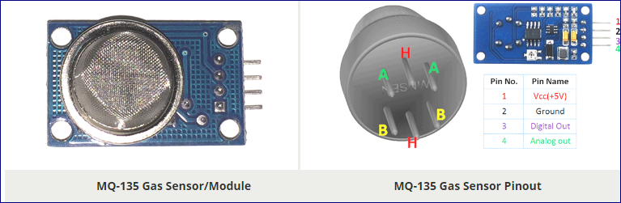

**Pin configuration :**

|  |  |  |
| --- | --- | --- |
| Pin No: | Pin Name: | Description |
| For Module | | |
| 1 | Vcc | Used to power the sensor, Generally the operating voltage is +5V. |
| 2 | Ground | Used to connect the module to system ground. |
| 3 | Digital Out | You can also use this sensor to get digital output from this pin, by setting a threshold value using the potentiometer. |
| 4 | Analog Out | This pin outputs 0-5V analog voltage based on the intensity of the gas. |
| For Sensor | | |
| 1 | H -Pins | Out of the two H pins, one pin is connected to supply and the other to ground |
| 2 | A-Pins | The A pins and B pins are interchangeable. These pins will be tied to the Supply voltage. |
| 3 | B-Pins | A pins and B pins are interchangeable. One pin will act as output while the other will be pulled to ground. |

**MQ-135 Sensor Features**

* Wide detecting scope
* Fast response and High sensitivity
* Stable and long life
* Operating Voltage is +5V
* Detect/Measure NH3, NOx, alcohol, Benzene, smoke, CO2, etc.
* Analog output voltage: 0V to 5V
* Digital output voltage: 0V or 5V (TTL Logic)
* Preheat duration 20 seconds
* Can be used as a Digital or analog sensor
* The Sensitivity of Digital pin can be varied using the potentiometer

**0.96 inch I2C/IIC 128x64 OLED Display Module 4 Pin**

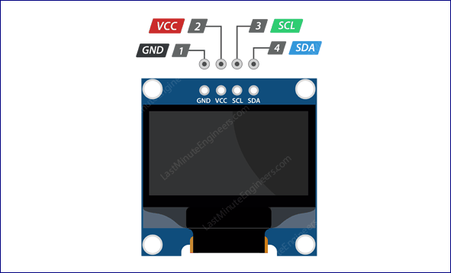

GND should be connected to the ground of Arduino

VCC is the power supply for the display which we connect the 5 volts pin on the Arduino.

SCL is a serial clock pin for I2C interface.

SDA is a serial data pin for I2C interface.

**Connections:**

* VCC pin to the 5V output on the Arduino
* GND to ground
* SCL is connected to pin A5 of arduino nano
* SDA is connected to pin A4 of arduino nano

**TINERCAD PLAYGROUND :**

Visit [TINKERCAD](https://www.tinkercad.com/things/c5qt1CwyIoA) to check live stimulation on tinkercad playground.

Also visit [VIDEO](https://drive.google.com/file/d/142EQS4xu3rDvMHQ3KwjbZVtvGprCWU-K/view?usp=drivesdk) for explanation on working for the same .

We have used default components which are present in tinkercad playground.( eg arduino uno)

**Snapshots:**

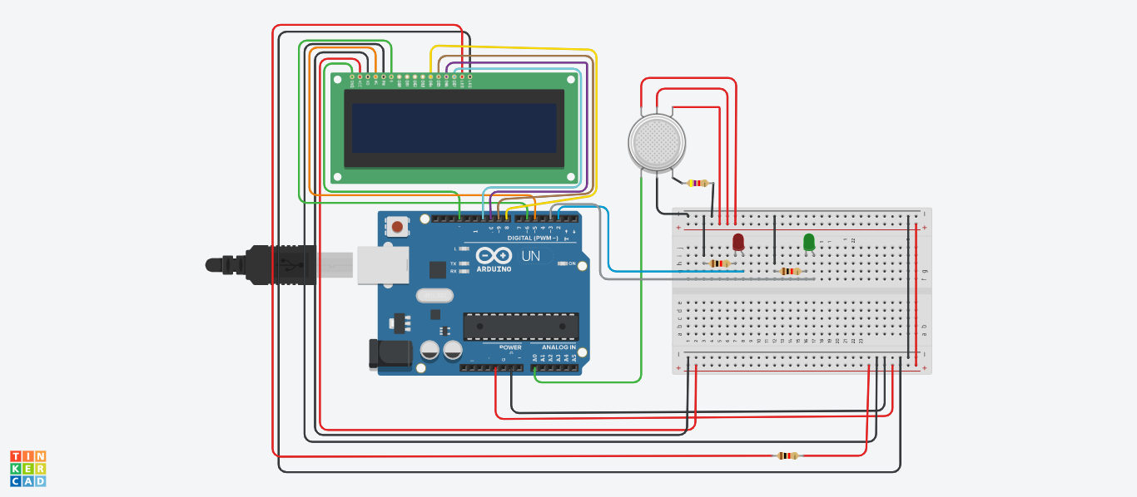

A smoke is used as demonstration to CO2 concentration .

When concentration is high near the sensor, display shows “HIGH PPM CONCENTRATION” and RED LED is turned ON .

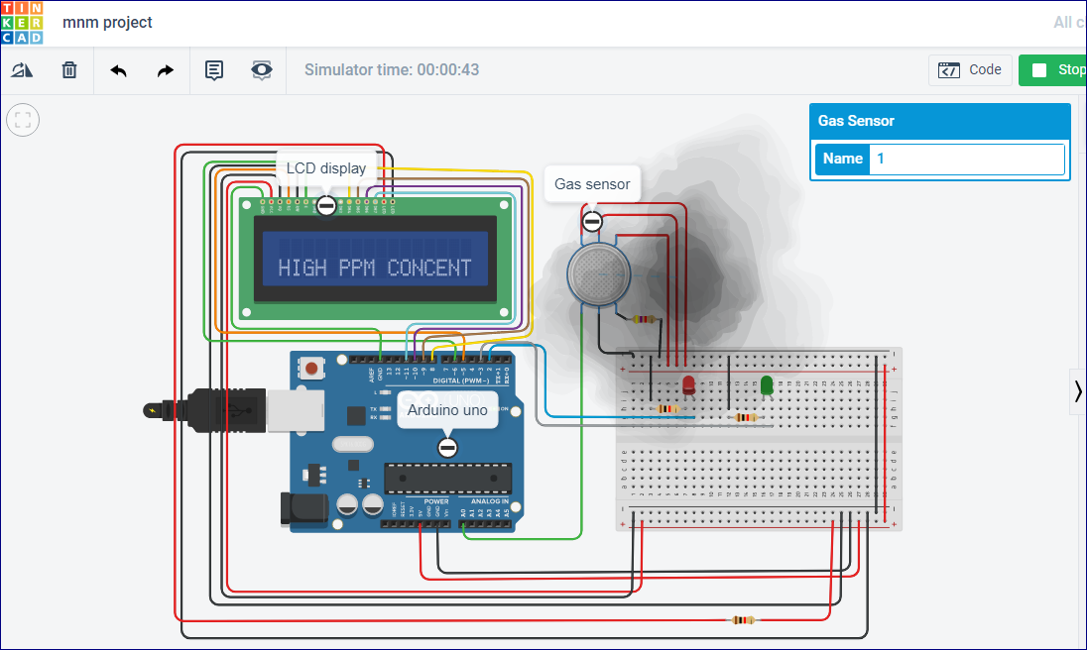

When concentration is low near the sensor, display shows “MODERATE PPM CONCENTRATION” and GREEN LED is turned ON .

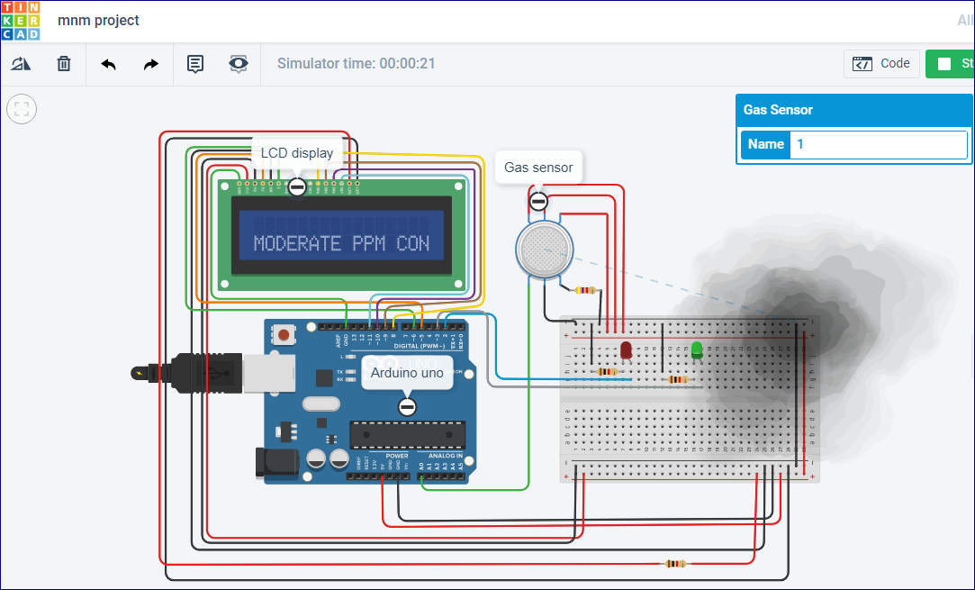

**IMPLEMENTING THE PROJECT :**

Please check out YOUTUBE (link) video for live demonstration.

CODE:

#include <SPI.h>

#include <MQ135.h>

#include <Wire.h>

#include <Adafruit_GFX.h>

#include <Adafruit_SSD1306.h>

Adafruit_SSD1306 display(-1);

MQ135 gasSensor = MQ135(A0);

int val;

int sensorPin = A0;

int sensorValue = 0;

void setup() {

// initialize with the I2C addr 0x3C

gasSensor = MQ135(A0);

Serial.begin(9600);

pinMode(sensorPin, INPUT);

display.begin(SSD1306_SWITCHCAPVCC, 0x3C);

display.clearDisplay();

}

void loop() {

// put your main code here, to run repeatedly:

display.setTextSize(3);

float rzero = gasSensor.getRZero();

float ppm = gasSensor.getPPM();

Serial.print ("ppm: ");

Serial.println (ppm);

display.setTextSize(1.2);

display.setTextColor(WHITE);

display.setCursor(0,28);

display.print("ppm ");

display.println(ppm);

display.display();

delay(200);

display.clearDisplay();

}

SNAPSHOTS:

**SERIAL OUTPUT OF PPM CONCENTRATION :**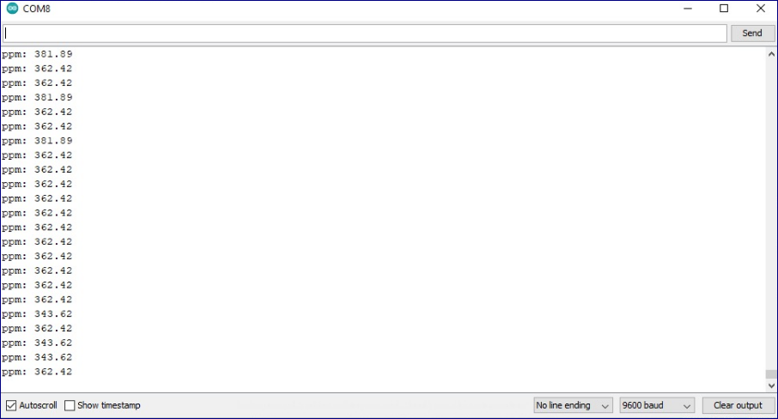

**GRAPHICAL REPRESENTION / ANALYSIS OF PPM CONCENTRATION**

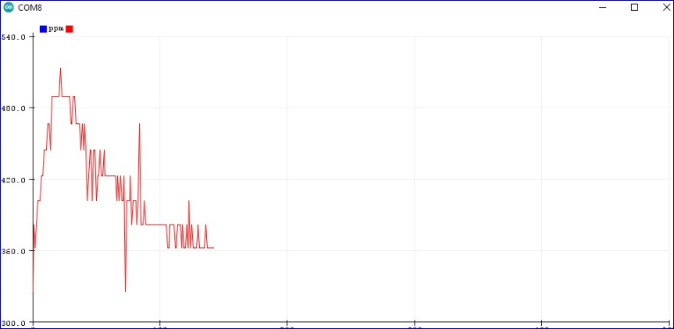

**SETUP IN WORKING CONDITION :**

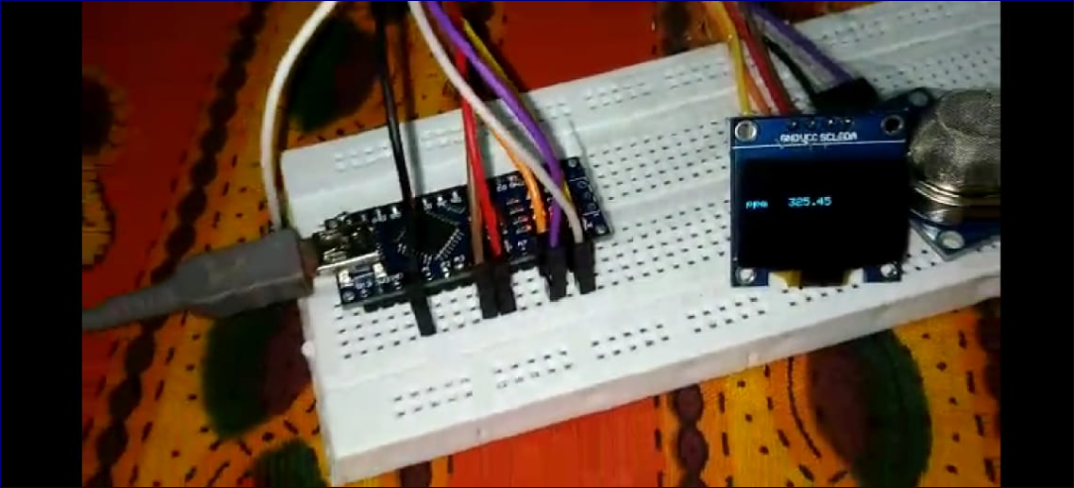

**LIMITATIONS:**

* + The sensor (like commercial ones) undergoes some delay in measuring the concentration of CO2.
  + The measurement range is 0–9999 ppm. Concentrations not included in this range will not be measured
  + Extreme relative humidity, temperature, and voltage can affect the measurements

**Checkout Github (** [**link**](https://github.com/ashish-3916/Arduino-project) **) for the complete project .**